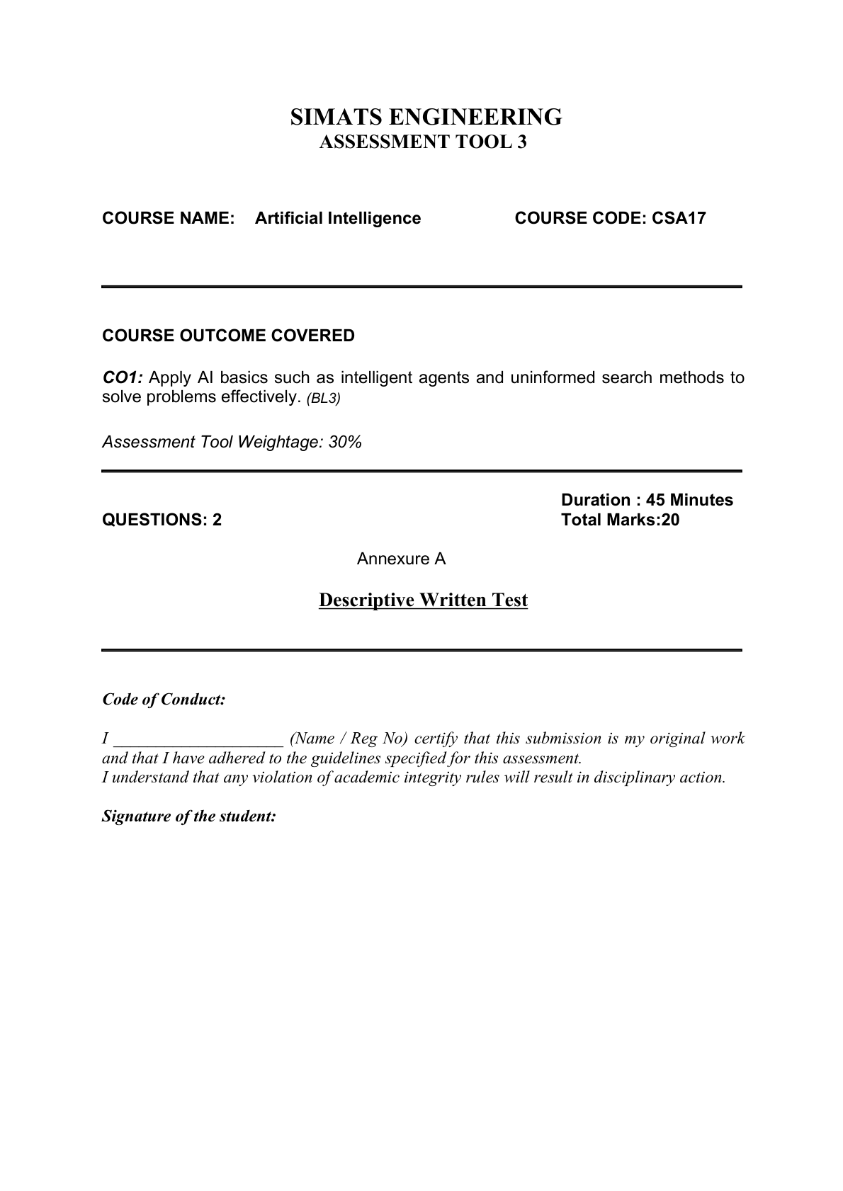
NANDHITHA,P (1965260011)
Annexure A
Descriptive Written Test
1. A smart home automation system is being designed to manage lighting, temperature, and security based on user behavior and environmental conditions. The system must respond to real-time inputs such as motion detection, temperature changes, and time of day while also learning user preferences over time. In this context, explain the different types of intelligent agents (simple reflex, model-based, goal-based, and utility-based agents) and analyze how each type would function within this system. Justify which type of agent or hybrid approach would be most effective for ensuring comfort, energy efficiency, and security.
ANSWER
An intelligent agent is a system that perceives its environment through sensors and takes actions through actuators to achieve a desired result. In a smart home, the sensors can detect motion, temperature, light, time, and security events, while actuators control lights, air conditioning, alarms, and other devices.
1. Simple Reflex Agent
A simple reflex agent selects an action directly from the current percept using condition-action rules. It does not remember previous states.
Example: If motion is detected in a room, turn on the light. If no motion is detected, turn the light off after a fixed period. Similarly, if the temperature is above a threshold, switch on the air conditioner.
Advantage: Fast and simple, with low computational requirements.
Limitation: It cannot use past information or learn user preferences, so it may make poor decisions when the current observation alone is insufficient.
2. Model-Based Agent
A model-based agent maintains an internal state of the environment. It uses the current sensor information together with stored information about what has happened previously.
Example: If the system knows that a person entered the room a few minutes ago and motion is temporarily absent, it can avoid immediately turning the lights off. It can also maintain the known status of doors, windows, lights, and temperature.
Advantage: Works better in partially observable situations because it maintains internal information.
Limitation: More complex than a simple reflex agent and requires maintaining an accurate internal model.
3. Goal-Based Agent
A goal-based agent selects actions that help it achieve a specified goal.
Example: A goal may be to maintain a comfortable room temperature, turn lights on when a person needs them, or secure the house when occupants leave. The agent evaluates possible actions according to whether they help achieve these goals.
Advantage: More flexible because it can select different actions to reach a goal.
Limitation: It mainly considers whether goals are achieved and may not distinguish sufficiently between several solutions with different levels of comfort, cost, or energy use.
4. Utility-Based Agent
A utility-based agent chooses an action by considering how desirable the possible outcomes are. It can balance several competing objectives.
Example: The smart home may keep a room comfortable while minimizing electricity consumption and maintaining security. Instead of simply turning the air conditioner on whenever the temperature rises, it can consider temperature, occupancy, time, energy consumption, and user preferences before selecting an action.
Advantage: Best suited to situations with multiple competing objectives because it can compare alternatives using a utility measure.
Limitation: Designing the utility function and collecting reliable information can be more complex.
Comparison in the smart home:
Agent | How it works | Smart-home example | Main limitation
Simple Reflex | Uses current input and rules. | Motion → light ON. | No memory or learning.
Model-Based | Uses current input + internal state. | Tracks occupancy and device status. | More complex.
Goal-Based | Chooses actions to reach goals. | Maintain comfort or security. | Does not naturally rank all outcomes.
Utility-Based | Chooses the most desirable outcome. | Balance comfort, energy and security. | Utility design is complex.
Most effective approach: A hybrid model-based, goal-based, and utility-based agent would be the most effective. The model-based part maintains information about the home and user behavior. The goal-based part ensures that important objectives such as comfort and security are achieved. The utility-based part allows the system to balance comfort, energy efficiency, cost, and security. Simple reflex rules can still be used for urgent actions such as immediately activating an alarm when a security condition is detected.
Therefore, a hybrid agent provides the best overall solution because a smart home must react quickly, remember relevant information, achieve goals, and make rational trade-offs between comfort, energy efficiency, and security.

2. A robot is placed in an unknown maze and must find a path to the exit without prior knowledge of the layout. Explain how uninformed search strategies like Uniform Cost Search (UCS) and Iterative Deepening Search (IDS) can help solve this problem. Discuss the advantages and disadvantages of these algorithms in terms of time and space complexity. Relate the problem to different types of intelligent agents and explain how agent design affects decision-making. Suggest which combination of agent type and search strategy would be most effective and justify your choice.
ANSWER
In an unknown maze, the robot does not initially know the positions of all paths, walls, or the exit route. Uninformed search methods do not use a heuristic estimate of the distance to the goal. They systematically explore the available states until the exit is found.
1. Uniform Cost Search (UCS)
UCS expands the node with the smallest path cost g(n). If every movement has the same cost, UCS behaves similarly to breadth-first search. If movement costs differ, UCS can still find the least-cost path.
Steps: Start from the initial state → place it in a priority queue → select the state with the lowest accumulated cost → expand its available neighbouring cells → add/update them in the queue → repeat until the exit is selected.
Time complexity: O(b^(1 + floor(C*/ε))) in the general unequal-cost case, where b is the branching factor, C* is the optimal solution cost, and ε is the minimum positive step cost. For equal unit costs, it is commonly expressed as O(b^(d+1)).
Space complexity: O(b^(1 + floor(C*/ε))) because UCS stores the frontier and explored information. For unit costs it is commonly expressed as O(b^(d+1)).
Advantages: Complete when step costs are positive and optimal for path cost. It is suitable when different paths can have different costs.
Disadvantages: It can use a large amount of memory and may expand many nodes before reaching the goal.
2. Iterative Deepening Search (IDS)
IDS repeatedly performs depth-limited depth-first searches. It first searches to depth 0, then depth 1, then depth 2, and continues increasing the depth limit until the goal is found.
Steps: Set depth limit to 0 → perform depth-limited DFS → if the goal is not found, increase the limit by 1 → repeat until the exit is reached.
Time complexity: O(b^d), where b is the branching factor and d is the depth of the shallowest goal.
Space complexity: O(bd), which is much smaller than UCS's frontier storage in typical tree-search analysis.
Advantages: Uses much less memory than UCS and is complete for finite branching when the shallowest goal exists.
Disadvantages: It repeatedly expands nodes from earlier depth levels. It is optimal for equal step costs when the goal is shallow, but it is not generally optimal when path costs differ.
3. Intelligent-agent relationship
A simple reflex agent would choose actions from the current percept only. In a maze, this can cause repeated or poor decisions because it does not maintain a useful history.
A model-based agent maintains an internal representation of explored cells, walls, and previously visited locations. This is useful in an unknown maze because the robot can update its knowledge as it moves.
A goal-based agent selects actions that help achieve the goal of reaching the exit. Search algorithms can be used to determine a sequence of actions that reaches the goal.
A utility-based agent can choose between alternatives according to a measure such as travel cost, time, or safety. It is useful when different routes have different costs.
Agent design affects decision-making because the agent's internal state, goals, and evaluation criteria determine which actions it considers and selects.
4. Most effective combination
For an unknown maze, a model-based, goal-based agent combined with an appropriate search strategy is most effective. The model-based component stores the robot's growing knowledge of the maze, while the goal-based component focuses the robot on reaching the exit.
If all movements have equal cost and memory is limited, IDS is attractive because its space requirement is small. If path costs can differ and finding the least-cost route is important, UCS is more appropriate because it expands the lowest-cost path first and is optimal for positive step costs.
Therefore, for the stated problem where the main requirement is to find a path in an unknown maze, a model-based goal-based agent with IDS is a good memory-efficient choice when movements have equal cost. If the maze has different movement costs, a model-based goal-based agent with UCS is the stronger choice because it guarantees a minimum-cost solution under the required conditions.

